Userguide Gym-appen

What is Gym-appen?
Gymappen are a new Training diary. In gym-appen a user can:
- Doing a routine/Workout
- Create an own routines and exercises
- See all workouts that has been completed
- Be able to see statistics over progress

This guide will explain how Gym-appen works step by step and all of its features.

Innehåll
What is Gym-appen? 1
Introduction 3
Start menu: 3
Exercise 3
Add an exercise 3
For cardio: 4
Edit a exercise 6
Workout 7
Create a new workout 7
Edit a workout 7
Do a workout 7
See all performed workouts 8
See statistics over training 8
Statistics 8
Profile 8
Settings 8

Introduction

Start menu:
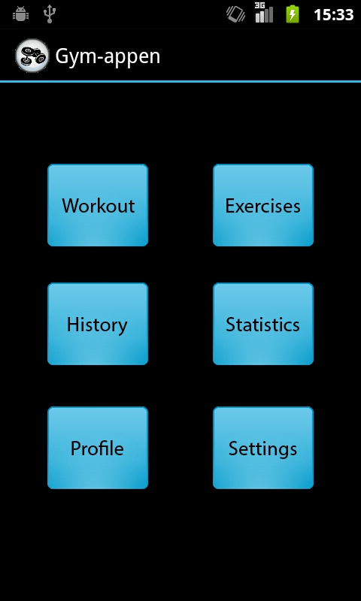
Figure 1 when you start gymappen, it will look like this
A short explanation on what will happen when pressing the buttons in the figure above:
- The gym-app icon in the top left corner takes the user back to the start menu(back to Figure 1)
- Workout: See all routines that has been added
- Exercises: See all exercises that is available.
- History: See all routines that has been completed
- Statistics: See statistics about over its training
- Profile: Fill in information about itself
- Settings: Change settings for Gymappen

Exercise

Add an exercise
- From the start menu, press the “exercise”-icon and a list will appear with the exercises that are available.
- Push the icon “Add Exercise” at the right top and a dialog will be shown.
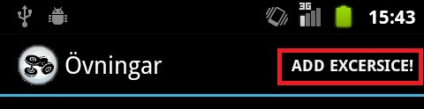
- Write the name for the exercise and then press the button “add”
- Now, let’s put in some attributes for the exercise. Choose what type of training it is. Choose between: Cardio, Static or a dynamic exercise 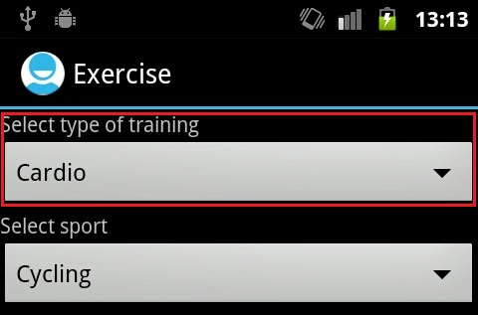

For cardio:
What sport to be added. The two text fields that follow after are optional and will contain a description about the exercise and some extra note to the user itself.
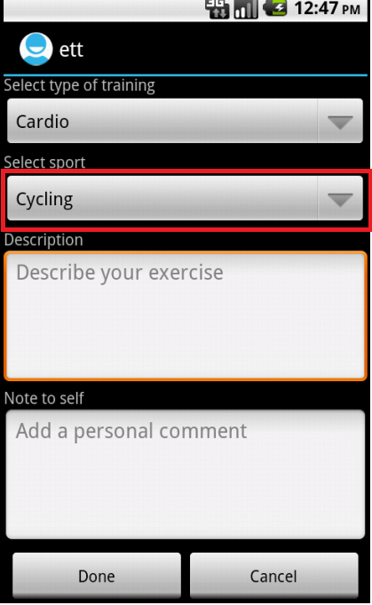
For Static and dynamic:
Choose primary(the first item) and secondary(the second item) muscle group. The two text fields that follow after are optional and will contain a description about the exercise and some extra note to the user itself.
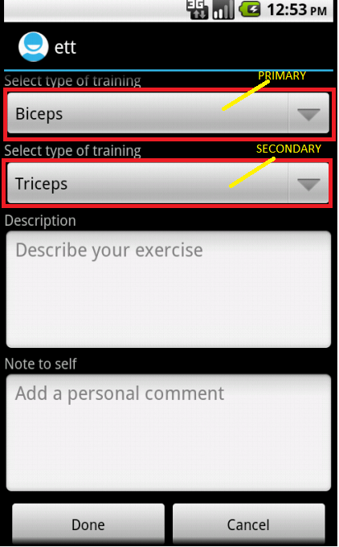
- Then press done and now the exercise has been added

Edit a exercise
- From the start menu, press the “exercise”-icon and a list will appear with the exercises that are available.
- Press the exercise that shall be edited.
- Then do step 4-6 in “Add an Exercise”.

Workout

Create a new workout
- Press the “Workout”-icon from the start menu.
- Thereafter press the icon “Add Workout” that is placed on the top left corner. Redirects to a dialog.
- Thereafter, write the name that the workout shall have.
- A list will be displayed with all the exercises. Pick the exercise by clicking it and the checkbox to the right of the exercise will be “checked”. (LÄGG TILL BILD)
Since every exercise has a muscle, every exercise is sorted by muscle. Press the item that are shown in the picture below and a list will appear with all the muscle groups and cardio will be shown. If a muscle group is pressed, all exercise that has this muscle group as its primary muscle.
- Press save and all of the exercises are now saved in the workout.

Edit a workout

- Press the Workout-icon from the start menu.
- Press the workout that shall be edited.
- Press “Edit Workout”-icon that are placed in the top left corner.
- Do step 4 and 5 in “Create a new workout”

Do a workout

- From the start menu press the workout-icon.
- Press the workout that shall be used
- Now click the exercise that shall be done.
At the top of every exercise there will be listed a “last time” text field. This place will list how many reps and how much weight that was lifted or for how long the exercise was done and the distance.
For a dynamic-exercise
Fill in how many repetitions that was done and how much weight that were used. Do this for every set that are done.
For a static-exericse
Fill in how long time the exercise were done in minutes and seconds and also fill in the weight amount that were added(if no extra weight, write zero).
For cardio
Fill in for how long time the exercise were done in minutes and seconds and also write the distance.
If the set were wrong that recently were added, just press the button “Remove set” and the last added set will be removed.
When you have finished your exercise, press done.
- When finished with workout, do (ADD MORE TEXT!!!!!!!!!!!!!!!!!!!!!!!!!)

See all performed workouts
- From the start menu click history button.
- You now se a list with all workouts you performed.
The big text is the name of that workout and under is the date you performed the workout.
- To see what exercises you had in your workout just push the workout you want to see and now you see all exercises with the weight and reps you performed.

Statistics

View statistics
- From the start menu click statistics button.
- From the dropdown menu choose what exercise/category you want to view statistic for.
- Statics up under the menu.

Add statistics
- From the start menu click statistics button.
- Click add

Profile

Settings

